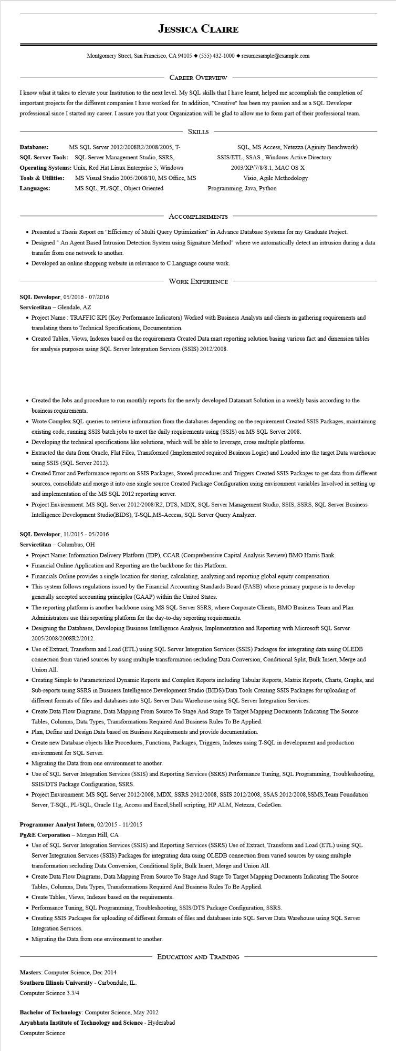
JESSICA CLAIRE
Montgomery Street, San Francisco, CA 94105 ♦ (555) 432-1000 resumesample@example.com
CAREER OVERVIEW
I know what it takes to elevate your Institution to the next level. My SQL skills that I have learnt, helped me accomplish the completion of important projects for the different companies I have worked for. In addition, "Creative" has been my passion and as a SQL Developer professional since I started my career. I assure you that your Organization will be glad to allow me to form part of their professional team.
SKILLS
Databases:
MS SQL Server 2012/2008R2/2008/2005, T-
SQL Server Tools: SQL Server Management Studio, SSRS, Operating Systems: Unix, Red Hat Linux Enterprise 5, Windows Tools & Utilities:
Languages:
MS Visual Studio 2005/2008/10, MS Office, MS
MS SQL, PL/SQL, Object Oriented
SQL, MS Access, Netezza (Aginity Benchwork) SSIS/ETL, SSAS, Windows Active Directory 2003/XP/7/8/8.1, MAC OS X Visio, Agile Methodology
Programming, Java, Python
ACCOMPLISHMENTS
• Presented a Thesis Report on "Efficiency of Multi Query Optimization" in Advance Database Systems for my Graduate Project.
• Designed " An Agent Based Intrusion Detection System using Signature Method" where we automatically detect an intrusion during a data transfer from one network to another.
• Developed an online shopping website in relevance to C Language course work.
WORK EXPERIENCE
SQL Developer, 05/2016 - 07/2016
Servicetitan - Glendale, AZ
• Project Name: TRAFFIC KPI (Key Performance Indicators) Worked with Business Analysts and clients in gathering requirements and translating them to Technical Specifications, Documentation.
• Created Tables, Views, Indexes based on the requirements Created Data mart reporting solution basing various fact and dimension tables for analysis purposes using SQL Server Integration Services (SSIS) 2012/2008.
• Created the Jobs and procedure to run monthly reports for the newly developed Datamart Solution in a weekly basis according to the business requirements.
• Wrote Complex SQL queries to retrieve information from the databases depending on the requirement Created SSIS Packages, maintaining existing code, running SSIS batch jobs to meet the daily requirements using (SSIS) on MS SQL Server 2008.
• Developing the technical specifications like solutions, which will be able to leverage, cross multiple platforms.
• Extracted the data from Oracle, Flat Files, Transformed (Implemented required Business Logic) and Loaded into the target Data warehouse using SSIS (SQL Server 2012).
• Created Error and Performance reports on SSIS Packages, Stored procedures and Triggers Created SSIS Packages to get data from different sources, consolidate and merge it into one single source Created Package Configuration using environment variables Involved in setting up and implementation of the MS SQL 2012 reporting server.
• Project Environment: MS SQL Server 2012/2008/R2, DTS, MDX, SQL Server Management Studio, SSIS, SSRS, SQL Server Business Intelligence Development Studio(BIDS), T-SQL,MS-Access, SQL Server Query Analyzer.
SQL Developer, 11/2015 - 05/2016
Servicetitan - Columbus, OH
• Project Name: Information Delivery Platform (IDP), CCAR (Comprehensive Capital Analysis Review) BMO Harris Bank.
• Financial Online Application and Reporting are the backbone for this Platform.
• Financials Online provides a single location for storing, calculating, analyzing and reporting global equity compensation.
• This system follows regulations issued by the Financial Accounting Standards Board (FASB) whose primary purpose is to develop generally accepted accounting principles (GAAP) within the United States.
• The reporting platform is another backbone using MS SQL Server SSRS, where Corporate Clients, BMO Business Team and Plan Administrators use this reporting platform for the day-to-day reporting requirements.
• Designing the Databases, Developing Business Intelligence Analysis, Implementation and Reporting with Microsoft SQL Server 2005/2008/2008R2/2012.
• Use of Extract, Transform and Load (ETL) using SQL Server Integration Services (SSIS) Packages for integrating data using OLEDB connection from varied sources by using multiple transformation secluding Data Conversion, Conditional Split, Bulk Insert, Merge and Union All
• Creating Simple to Parameterized Dynamic Reports and Complex Reports including Tabular Reports, Matrix Reports, Charts, Graphs, and Sub-reports using SSRS in Business Intelligence Development Studio (BIDS)/Data Tools Creating SSIS Packages for uploading of different formats of files and databases into SQL Server Data Warehouse using SQL Server Integration Services.
• Create Data Flow Diagrams, Data Mapping From Source To Stage And Stage To Target Mapping Documents Indicating The Source Tables, Columns, Data Types, Transformations Required And Business Rules To Be Applied.
• Plan, Define and Design Data based on Business Requirements and provide documentation.
• Create new Database objects like Procedures, Functions, Packages, Triggers, Indexes using T-SQL in development and production environment for SQL Server.
• Migrating the Data from one environment to another.
• Use of SQL Server Integration Services (SSIS) and Reporting Services (SSRS) Performance Tuning, SQL Programming. Troubleshooting, SSIS/DTS Package Configuration, SSRS.
• Project Environment: MS SQL Server 2012/2008, MDX, SSRS 2012/2008, SSIS 2012/2008, SSAS 2012/2008,SSMS, Team Foundation Server, T-SQL, PL/SQL, Oracle 11g, Access and Excel, Shell scripting, HP ALM, Netezza, CodeGen.
Programmer Analyst Intern, 02/2015 - 11/2015
Pg&E Corporation - Morgan Hill, CA
• Use of SQL Server Integration Services (SSIS) and Reporting Services (SSRS) Use of Extract, Transform and Load (ETL) using SQL Server Integration Services (SSIS) Packages for integrating data using OLEDB connection from varied sources by using multiple transformation secluding Data Conversion, Conditional Split, Bulk Insert, Merge and Union All.
• Create Data Flow Diagrams, Data Mapping From Source To Stage And Stage To Target Mapping Documents Indicating The Source Tables, Columns, Data Types, Transformations Required And Business Rules To Be Applied.
• Create Tables, Views, Indexes based on the requirements.
• Performance Tuning, SQL Programming, Troubleshooting, SSIS/DTS Package Configuration, SSRS.
• Creating SSIS Packages for uploading of different formats of files and databases into SQL Server Data Warehouse using SQL Server Integration Services.
• Migrating the Data from one environment to another.
Masters: Computer Science, Dec 2014
Southern Illinois University - Carbondale, IL.
EDUCATION AND TRAINING
Computer Science 3.3/4
Bachelor of Technology: Computer Science, May 2012
Aryabhata Institute of Technology and Science - Hyderabad Computer Science

